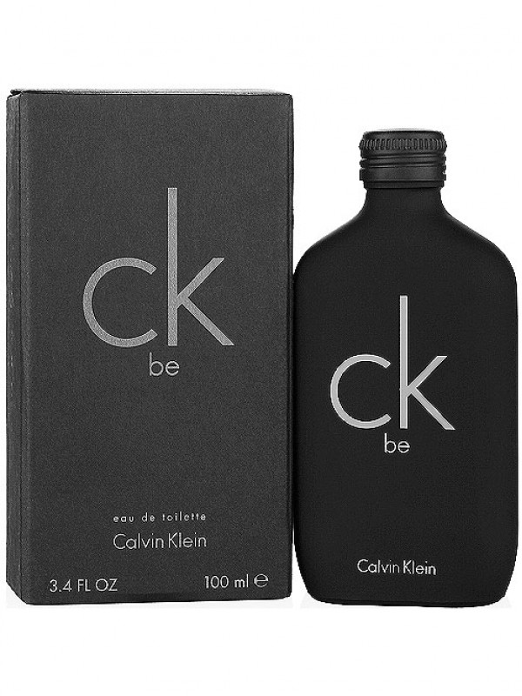

The idea of the fragrance is "be-yourself". Transparent, silky and very sexy.

A fresh woody fragrance unisex with a fresh opening of bergamot, mandarin, juniper, lavender, peppermint and green notes. In the heart of the composition is jasmine, orchid, freesia, magnolia with a fresh hint of peach. There are cedar, amber, musk, sandal and vanilla in the base.

The perfume was created by Ann Gottlieb 1996.

Two popular fragrances CK One and CK Be by the house of Calvin Klein were introduced in 2009 as limited edition in a special and very interesting collection called WE ARE ONE.

Brand Name: Calvin Klein

Product Code: SH-CK-6941

Quantity (ML) 100 ML

Made: Imported

Gender: Male

Price: Rs.2,999/-